Entitas yang ada pada sistem ini:

- client customer

- client merchant

- server

Jenis layanan yang digunakan: user-confirmed connectionless

Service Primitives and Parameters:

|  |  |  |
| --- | --- | --- |
| Service Elements | Service Primitives | Service Parameters |
| Login | LoginRequest | Email, Password |
| LoginIndication | Email, Password |
| LoginResponse | Confirmation |
| LoginConfirm | Confirmation |
| Pembayaran Terakhir | LastPaymentRequest | Authentication Token, Account |
| LastPaymentIndication | Authentication Token, Account |
| LastPaymentResponse | Last Payment History (Time, Nominal, Tujuan Pembayaran) |
| LastPaymentConfirm | Last Payment History (Time, Nominal, Tujuan Pembayaran) |
| Pembayaran 1 hari | DailyPaymentRequest | Authentication Token, Account, Request Date |
| DailyPaymentIndication | Authentication Token, Account, Request Date |
| DailyPaymentResponse | List of Daily Payment History (Time, Nominal, Tujuan Pembayaran) |
| DailyPaymentConfirm | List of Daily Payment History (Time, Nominal, Tujuan Pembayaran) |
| Pembayaran 1 minggu | WeeklyPaymentRequest | Authentication Token, Account, Request Date |
| WeeklyPaymentIndication | Authentication Token, Account, Request Date |
| WeeklyPaymentResponse | List of Weekly Payment History (Time sampai -7 hari dari Request Date, Nominal, Tujuan Pembayaran) |
| WeeklyPaymentConfirm | List of Weekly Payment History (Time sampai -7 hari dari Request Date, Nominal, Tujuan Pembayaran) |
| Logout | LogoutRequest | Authentication Token, Account |
| LogoutIndication | Authentication Token, Account |
| LogoutResponse | Confirmation |
| LogoutConfirm | Confirmation |

**Login Protocol**

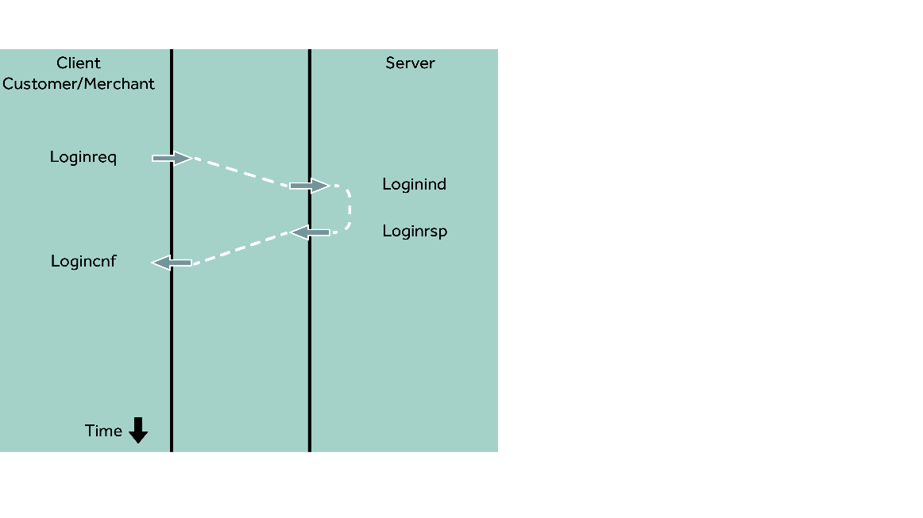

**Last Payment Protocol**

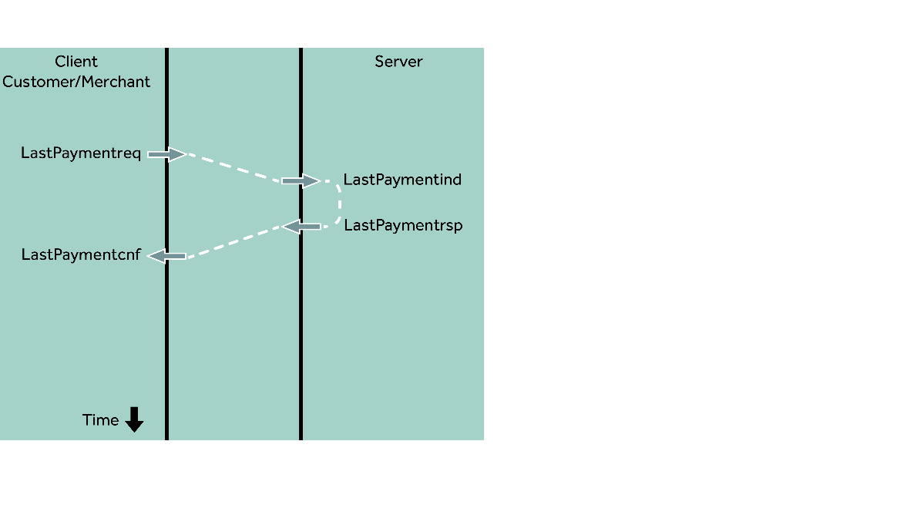

**Daily Payment Protocol**

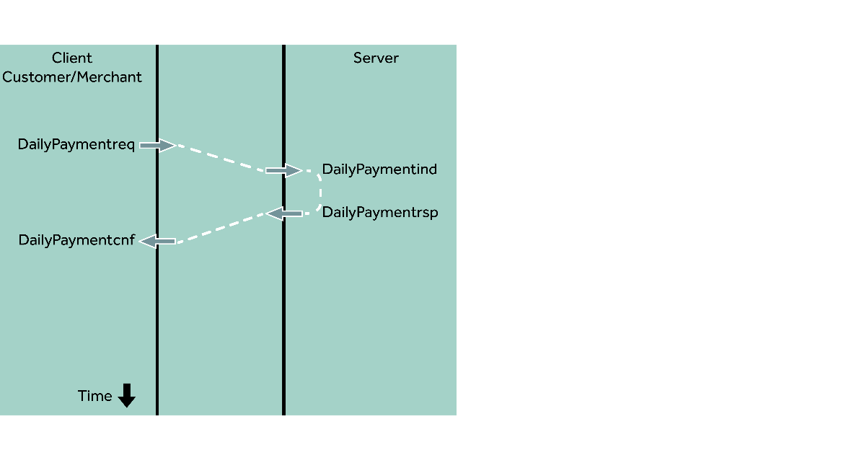

**Weekly Payment**

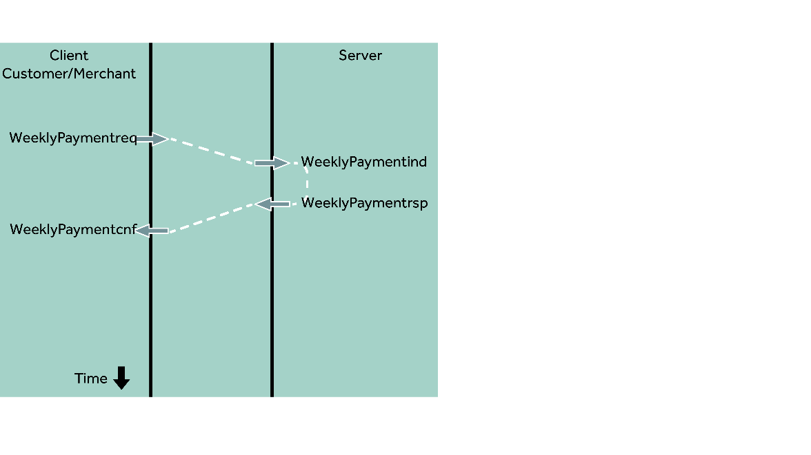

**Logout Protocol**

